UBND QUẬN HỒNG BÀNG

**TRƯỜNG TIỂU HỌC TRẦN VĂN ƠN**

**ĐÁP ÁN BÀI KIỂM TRA HỌC KÌ II: MÔN TIẾNG ANH LỚP 5**

**NĂM HỌC 2023-2024**

**LISTENING**

***Part 1. Questions 1 - 4. Listen and match. There is an example. (1pt)***

*Mỗi câu đúng được 0.25 điểm*

1. My sister takes lots of photos on weekend
2. He’s brushing his hair, now
3. What are they doing? – They are washing the car.
4. What’s she doing? – She’s singing

1. A 2. E 3. B 4. F

***PART 2: Question 5 – 7: Listen and number. There is one example.***  *(****0.75pt)***

*Mỗi câu đúng được 0.25 điểm*

1. What’s she doing ? – She is talking with her mother.
2. The birthday party was fun. Everybody was very happy.
3. My costume was a big red coat with a hood.

5. E 6. B 7. D

**Part 3. Questions 8-10. Listen and write. There is an example. (0.75pt)**

*Mỗi câu đúng được 0.25 điểm*

1. She’s wearing a blue shirt.
2. There were some teachers in the classroom.
3. They are talking with their friends

8. shirt 9. some 10. talking

**READING**

**Part 1. Questions 1-3. Look and read. Write the correct words next to the suitable description. There is an example.** *(0.75****pts)***

*Mỗi câu đúng được 0.25 điểm*

1. Bride 2. Scarf 3. Band

**Part 2. Questions 4-6. Read and circle. There is an example.** *(****0.75 pt)***

*Mỗi câu đúng được 0.25 điểm*

4. A 5. B 6. C

**Part 3. Questions 7-10. Read the text carefully. Write True(T) or False(F). There is an example.** *(****1pts)***

*Mỗi câu đúng được 0.25 điểm*

7. F 8. T 9. F 10. T

**WRITING**

**Part 1. Questions 1- 4. Look at the pictures and write. There is an example***(****0.75pt)***

*Mỗi câu đúng được 0.25 điểm*

1. dress. 2. rubbish 3. invitation 4. making

**Part 2. Questions 5–8. Reorder the words to make a correct sentence. There is an example.** *(****1pts)***

*Mỗi câu đúng được 0.25 điểm*

5. My cousin is wearing a green and yellow shirt. (My cousin is wearing a yellow and green shirt.

6. Peter was noisy and naughty.

7. There were not any students in the classroom.

8. Harry is talking to his friends in the wedding party.

**Part 3. Questions 9- 10. Answer about you. (0.5pt)**

*Mỗi câu đúng được 0.25 điểm*

9. I go to school ….. (at 7 o’clock, at three o’clock in the morning,……)

10. I was ….. (at home, in HCM city, ……..)

***************END****************

**SPEAKING GRADE 5 1st TERM**

Greeting & test taker’s name check.

The examiner says “My name is....... It’s nice to talk to you today.”

**PART 1: Getting to know each other**

1. What’s your name?

2. How do you spell your name?

3. How are you today?

**PART 2: Talking about a familiar object**

1. What subject?

2. When have you got it?

Do you like it? Why/Why not?

3. Tell me some school subjects that you like?

**PART 3: Describing the picture**

1. What do the people in the picture do?

What’s the time?

What time does he/she get up?

When doeshe/she skate?

2. What does your family often do in the evening?

Follow–up question:

When do you do your homework?

Do you watch TV in the evening?

Do you help your mum?

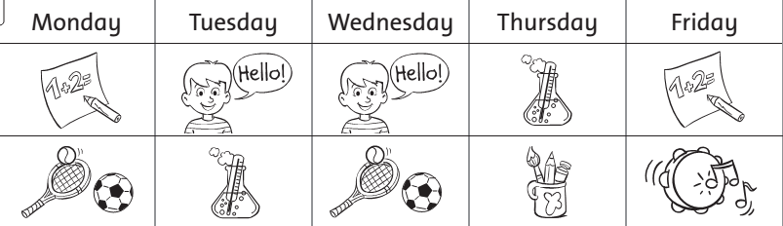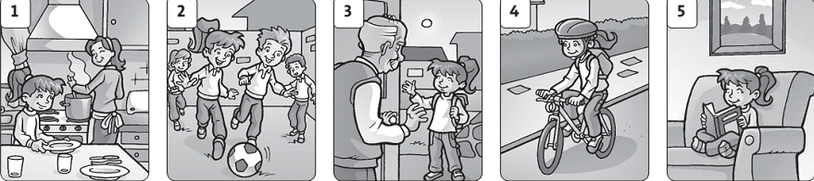

*\* Lưu ý đối với học sinh khuyết tật:*

*- Listening: Bỏ bài 2, tăng điểm ở bài 3- 0.75 điểm*

*- Reading: Bỏ bài 3, tăng điểm ở bài 2- 0.75 điểm*

*- Writing: Bỏ bài 2, tăng điểm ở bài 1- 1 điểm*

*- Speaking: Bỏ yêu cầu 3, tăng điểm ở yêu cầu 1 và 2 mỗi yêu cầu 0.5 điểm*

***************Hết****************